Mediation Services For Elder Issues and Estate Disputes

- Collaborative Family Decision Making
  - Living and Personal Care Arrangements
  - Health Care and Financial Decisions
  - Powers of Attorney Disputes
  - Avoiding Guardianships

- Estate Disputes
  - Trustee/Beneficiary Disagreements
  - Family Business Succession
  - Real Estate Matters
  - Asset Division

Kristy A. Christensen

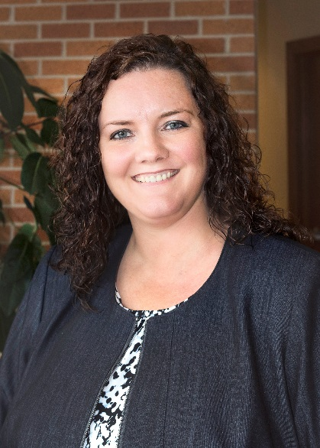

Contact Kristy
Direct Dial: 920.257.2254
kchristensen@mccarty-law.com

Kristy has a broad range of experience, handling private mediations and mediating with the Winnebago County Conflict Resolution Center. She has also served as counsel for both Plaintiffs and Defendants in numerous mediations. Kristy’s training includes 30 hours of Civil Mediation Skills Training, and a 30-hour Advanced Mediation Training in Elder Mediation.

