Mediation Services For Business and Commercial Disputes

  - Real Estate
- Property Line Disputes
- Breaches of Offer to Purchase
- Condition Report Misrepresentations
- Landlord/Tenant

  - Construction – Residential and Commercial
- Alleged Construction Defects
- Non-payment Issues
- Subcontractor and Vendor Issues

  - General Business
- Contract Disputes
- Collections Matters
- Business Dissolution

Kristy A. Christensen

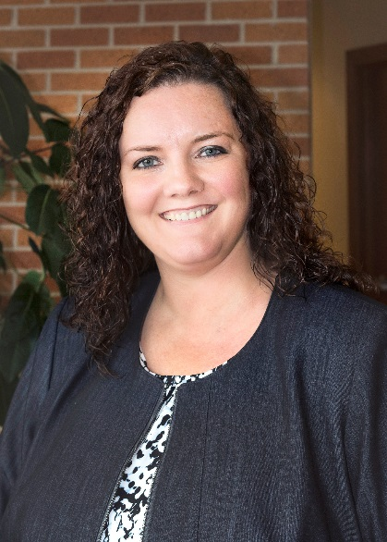

Contact Kristy
Direct Dial: 920.257.2254
kchristensen@mccarty-law.com

Kristy has a broad range of experience, handling private mediations and mediating with the Winnebago County Conflict Resolution Center. Kristy has also served as an arbitrator for the Home Builders Association of the Fox Cities. Additionally, she has served as counsel for both Plaintiffs and Defendants in numerous mediations over the last 14 years. Kristy’s formal mediation training includes 30 hours of Civil Mediation Skills Training, and a 30-hour Advanced Mediation Training in Elder Mediation.

